

community metrics playbook
best practices
Social media can be defined as the digital ecosystem where individuals can share experiences, thoughts, opinions, interests and even create bonds with other people or brand to build a community. As every relationship, the bond among community members should be nurtured and moderated, establishing guidelines and commitments from each part creating a long-term relationship.

Every social media platform was created with the intention to link people from one another but with a different goal in mind defining four steps into the funnel to a healthy community.

Forums LinkedIn Reddit Twitter
Facebook Instagram Snapchat YouTube

Snapchat Friends YouTube Subscribers Tumblr
Facebook Fans Twitter Followers Instagram Followers Events

Pinterest Stack Overflow
Twitter Replies YouTube Replies

Facebook Page Pinterest Stack Overflow
Twitter Pinterest Stack Overflow

DEFFINING SUCCESS
There is not a simple way of defining success. This will depend on the channel of communication.
- Follower Rate – The speed at which fans are obtained will be determined by the relevance of the story and the channel through where it is being communicated.
- Engagement Rate– The number of likes, comments, shares or participants based on the total number of attendees/viewers. A higher consumer engagement is a sign of great content!
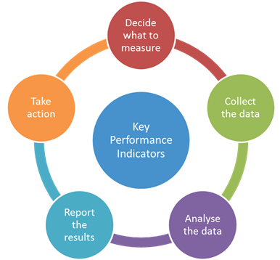
- Social Sentiment – It’s not possible to make every user happy but sustaining 75% positive sentiment over time is important.
- Advocacy – Word of mouth recommendations from community members. This is achieved by a consistent message, offering and outstanding experience measured by the number of shares, reviews and feedback.
- ROI:
Social media
Media spend/number of earned followers

MSFT signups
Media spend/ number of sessions to the landing page
*for leads we will need the Facebook pixel or a lead generator tool

AUDIENCE
Before choosing a channel to communicate, we should define who our audience is (Creative, Commercial, Developer etc.) and what the message will be. The two major messaging approaches are driving sales and awareness (Marketing) and engaging and retaining users (Community).
Creative audience
Creators gather in communities searching for inspiration and recognition, the simple act of sharing their creations and getting likes is encouraging to keep creating more
Developer community
Developer communities exist as a learning experience for developers according to the programming language they are trying to learn and how fast they want to advance or get feedback.
Communities provide a platform for asking questions where users will be eager to provide insights, new perspectives, tips and links and research papers, and to make friends or meet potential partners.

SOCIAL MEDIA CHANNELS
Different channels are better at achieving these different goals. Work with your community Specialist to determine which are the right channels for you based on your target audience and demographics

Facebook
This is the most robust social media channel, it has a solution for every stage of the funnel from awareness to leadership, because of Facebook’s wide reach 1.13 billion daily active users, this social channel is recommended for awareness and membership strategies. 72% of adult internet users use Facebook
KPIS: Reach, video views, shares, %CTR, engagement, ROI

Instagram
Born as an alternative social channel to share pictures and video either publicly or privately, since it was acquired by Facebook, sponsored posts became available having two ultimate goals: drive people to a website and call to an offline store. Instagram is recommended for awareness campaigns, membership and ecommerce/offline store visits for millennials and younger users. Instagram has 500 million monthly active users. 59% of Instagram users are on the platform daily
KPIS: Reach, views, engagement rate, %CTR, Leads, ROI

Twitter
Is a news and social networking platform where users post and interact with messages, restricted to 140 characters. Twitter is highly recommended for belonging and leadership campaigns due to the 1:1 engagement with users. Twitter has 313 million monthly active users, 23% of adult internet users use Twitter.
KPIS: follower rate, engagement rate, reach

Snapchat
Is an image messaging and multimedia where pictures and messages are only available for a short time before they become inaccessible. This is highly recommended for awareness and membership campaigns targeted to millennials and younger audiences. Snapchat has 150 million daily active users. 30% of U.S. millennial users use Snapchat regularly.
KPIS: Views, followers/friends,

YouTube
First large-scale video sharing site which is available in over fifty languages and hosts all types of content: form movie trailers to amateur videos. YouTube is most recommended for awareness, membership and belonging campaigns uploading content in regular basis and engaging with your audience through comments. YouTube has over a billion users, almost one-third of all people on the Internet. Two-thirds of YouTube users watch YouTube on a second screen while watching TV at home.
KPIS: channel subscribers, video views, engagement rate, shares

Tumblr
Microblogging platform and social network which allows users to post multimedia and other content to a short form blog available in 18 languages has a wider reach within the U.S. Recommended for membership strategy among millennial audience. Tumbler has 550 million monthly users. 42% of total traffic is from the U.S. and 69% are millennials.
KPIS: views, reach, shares, engagement rate, followers

LinkedIn
Business-oriented social networking service. LinkedIn has 450 million members, but only 25% actively visit the professional social network each month. LinkedIn is the only major social media platform for which usage rates are higher among 30- to 49-year-olds than among 18- to 29-year-olds. Its recommended for awareness focused on technical or research content.
KPIS: %CTR, Reach leads

Pinterest
Online pin board, a visual take on the social bookmarking site. Content shared on Pinterest is driven entirely by visuals. Pinterest is highly recommended for belonging and conversions for ecommerce. Pinterest has 100 million monthly active users. 31% of adult internet users use Pinterest.
KPIS: followers, %CTR, leads/conversions

Livestreaming
Live streaming video platforms broadcasts gameplay and creative activities. Every day activities are the most streamed. Live video is more appealing to brand audiences: 80% would rather watch live video from a brand than read a blog, and 82% prefer live video from a brand to social posts.
KPIS: subscribers, live views, total views

Reddit
Entertainment, social news networking service, and news website. Reddit’s registered community members can submit content such as text posts or direct links. Registered users can then vote submissions to organize the posts and determine their position on the site’s pages. This channel is most performing as a listening channel and awareness. Engagement will be most reactive and oriented to crisis management and clarifications. 81% of users are single white males between 18-35 years old. More than 50% of the users are based in the U.S. and 35.9% are windows users.
KPIS: sentiment, points (upvotes)

Quora
Question-and-answer site where questions are asked, answered, edited and organized by its community of users. Social listening is the highly recommended to provide answers to users before they become big issues, and gather user experience learnings, Quora has 80 million unique visitors - 50 percent in the U.S. and 15 percent from India.
KPIS: views, upvotes

Stack overflow
Privately held website, the flagship site of the slack exchange network, created to be a more open alternative to earlier question and answer sites. It is the largest community for programmers to learn, share their knowledge and advance in their careers. Recommended for listening and belonging within the dev community. 7.3 million programmers are members of the community.
KPIS: answers, views, votes, feedback items

Forums
Forums are internet sites where users can post comments about an issue or topic and reply to other users' postings; a message board. Recommended for listening and awareness campaigns.15% of internet users read or comment on discussion forums such as reddit, Digg, or Slashdot.
KPIS: sentiment

Events
Real Life events are the best way of getting feedback and insights from users and observe user challenges in real time within a small group or demographic. Recommended for membership, belonging and leadership campaigns. Types of events:
- Conventions
- meet ups
- seminars/workshops
KPIS: attendance, engagement, swag give away, social shares with a hashtag

Resources
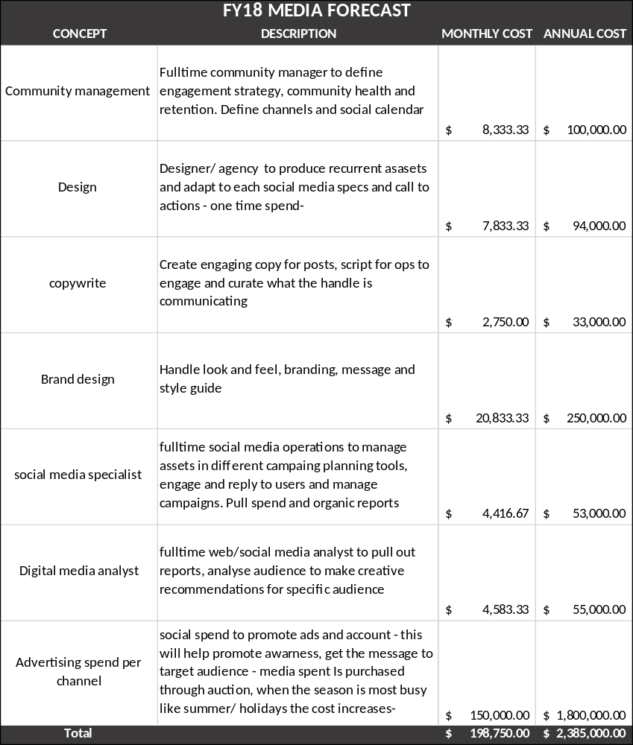
To manage social media handles successfully the basic costs will be:

RECOMMENDATIONS
- Select target audience and goal, with this information define channels.
- Create at least five assets/posts per channel following the same message and voice
- Stablish a cadence and reply to comments or questions
- Define from learnings which are the best days to post and times with more engagement

Glossary
Awareness: A measure of how well-known a brand, company or product is. As part of the purchase funnel, people can be made aware of your brand with or without the desire to purchase.
Branding: Cohesive positioning of the name of the product or brand.
Engagement and engagement rate
Leadership: Long term relationship with users where they are not only members of the community, but these users will nourish and preserve the health of it
Conversion: A descriptor encompassing an end user converting to a paying user or a user that performs an action of some sort.
Organic traffic or followers: Followers or engagement actions earned by the quality and frequency of content being posted.
Earned media or followers: Second-party distribution of a message at no cost to you.
Paid media or followers: Money spent to gain views, impressions or follows.
Bid auction: Purchase method to be showed to a specific audience. The highest bid with the most relevant content will be shown to users first.
CPM: Revenue model where the advertiser pays a set fee to the publisher for every 1,000 times the ad is displayed. CPC: Revenue model where the publisher is paid a certain amount each time a visitor clicks on an ad or link.
Creative: Unique words, design and display of a paid-space advertisement. In paid search advertising, creative refers to the ad's title (headline), description (text offer) and display URL (clickable link to advertiser's web site landing page). Unique creative display includes word emphasis (boldfaced, italicized, in quotes), typeface style, and on some site, added graphic images, logos, animation or video clips.
Leads: When a visitor registers, signs up for, or downloads something on a specific site. A lead might also comprise a visitor filling out a form
Pixel: An HTML object or code that transmits information to a third-party server. Pixels are used to track online user activity, such as viewing a web page or completing a conversion process.


